Models for Synchrophasor with Step Discontinuities in Magnitude and Phase: Estimation and Performance

Marcelo B. Martins, Renata de Barros e Vasconcellos, and Paulo A. A. Esquef, Member, IEEE

[1] ***Abstract —* This work proposes an alternative method to assess the calibration of phasor measurements units (PMUs) under conditions of step discontinuities in magnitude or phase. Two parametric mathematical models, which are proposed to represent these signals, are fitted to signal samples via an iterative numerical method. The proposed approach does not require any time adjustment of the analysis window to skip the discontinuity. The estimated parameters can be used to calculate frequency, magnitude, and phase during magnitude or phase steps. For the transitioning quantities, we propose reference phasors with an appropriate definition. Moreover, accurate estimates of the location and magnitude of the discontinuities are provided.**

***Index Terms —* Calibration, dynamic tests, phasor measurement units, synchrophasor, uncertainty.**

# INTRODUCTION

T

he dynamic behavior of modern electric grid demands testing the performance of phasor measurement units (PMUs) under magnitude steps and phase steps, as prescribed in the IEEE standard [1], along with its amendment [2]. The accuracy of those measurements depends on the reference values provided by PMU calibration systems. Recent developments towards the calibration of PMUs for distribution grids demand lower uncertainty levels than the first systems, which were designed for the context of transmission grids [3]. The calibration process depends on generating and sampling synchronized waveforms, from which reference phasors are compared to the values provided by the PMU under test. The synchrophasor is the phasor which phase is the angle relative to an ideal cosine function at the nominal system frequency with a time base centered in the Universal Time Code (UTC) second [1]. PMUs also provide estimates of frequency and rate of change of frequency (ROCOF) at a given report rate.

For the estimation of synchrophasors, a stationary phasor waveform can be curve fitted with a steady state sinusoidal function with sufficient accuracy [3]. Methods to estimate parameters of signals with slowly varying frequency, magnitude or phase, for PMU calibration purposes, are also presented in [3] and [4]. Typical variations in parameters or nonlinearities can be modeled by low order Taylor series expansion. Then, iterative procedures are used to estimate the model parameters.

The usual approach in previous works to deal with transient signals is to ignore the measurements obtained in windows containing disturbances [5] [6], along with some transient detector [7-9]. This approach can become inappropriate with the evolution of electric grid. One example is a recent report of measurement errors during fast transients caused the protection system of a solar power plant to cut it off the grid [10]. These occurrences point out the need for a deeper investigation on measurement errors during transients.

In the specific case of an observed phasor disturbed by a step discontinuity in magnitude or phase, the estimation using an underlying steady state model is inappropriate and does not guarantee convergence nor accuracy [11][12]. Besides, there is a lack of definition of what the reference phasor should be. To overcome this difficulty, the method used in [3] adjusts the timestamp and position of the analysis window to skip the discontinuity and sets the phasor estimates where the discontinuity occurs as those of obtained from the previous or following window. That way, it avoids the mathematical modelling of a step discontinuity and considers the reference value coming from the steady state.

The mentioned procedures are designed to calibrate PMUs, and may be not detailed enough to evaluate the performance of calibration systems. Methods for a more detailed analysis of calibration systems under step conditions are proposed in [13]. The authors use a pointwise root mean squared error for the performance evaluation of the investigated phasor estimators.

Although not trying to break the stationary paradigm of the phasor representation of a signal, we propose an alternative approach to assess the measurements of PMU calibration systems under step tests. The time instant of the step is the first useful information to be observed. Besides, we can obtain more information from the digitized signals using parametric models that incorporate magnitude or phase steps with appropriate numerical methods for the estimation of parameters. Other important observation is the underlying frequency during the transition of one steady state phasor to the next steady state condition. Furthermore, during a magnitude step, the phase is designed to remain constant and can be observed apart from the magnitude transient. Likewise, during a phase step, the magnitude stability can be observed while the phase changes. In addition, the estimated parameters can be used to estimate intermediate phasors that can be used as reference values during a PMU calibration.

For that, this extended version of [17] offers the following contributions:

1) Aiming at having accurate phasor estimates under transient conditions, we propose signal models that account for step discontinuities in magnitude or phase, incorporating representations of both the transient and the phasor.

2) Ways to estimate the parameters:

a) To use the instantaneous frequency as provided by the Hilbert transform of the perturbed phasor signal to estimate the instant of the step discontinuity;

b) To use a nonlinear least-square method (NL-LS) to estimate the other parameters of the models proposed in 1), provided the step instant estimate.

3) Proposition of single phasor estimate for transient situations, which can be used as reference values for PMU calibrations and easily implemented in the existing systems, in place of traditional estimation schemes. The proposed method depends on the estimation of parameters of an underlying model.

4) A preliminary evaluation of a laboratory system intended to be a PMU calibrator based on the aforementioned methods.

In order to assess the contribution to the uncertainty of the calibration system, we made simulations to obtain the numerical errors of each numerical method. In addition to this introduction, the paper is organized as follows: in section II, we present the mathematical background related to the proposed models for dynamic signals with magnitude or phase steps; the intermediary phasor definitions; and the basic concepts of the Hilbert transform and of the NL-LS method. In section III, we describe the Monte Carlo simulations run to analyze the numerical errors of each method. In section IV, we detail the Laboratory measurements devised to evaluate the use of the proposed system for PMU calibration. Finally, in section V, we discuss the attained results and draw conclusions on the reported investigation.

# Mathematical Background

## Mathematical models for dynamic signals

A pure sinusoidal waveform with one magnitude step, located at can be modeled in continuous time

, (1)

where is the step function. A similar model for the phasor waveform with one phase step is

, (2)

where the step function is used as an idealization of a fast transient in magnitude or phase occurring at the instant , where is the signal nominal magnitude, is a decimal value representing the magnitude change, is the amplitude of the phase step, is the angular frequency, is the initial phase, and represents interfering noise. Provided a sufficiently accurate estimate of , the set of parameters can then be adjusted to obtain a waveform that best fits the data received by the calibration system sampler,. Given a prescribed signal to noise ratio (SNR) in dB, for a zero mean gaussian white noise, the variance of noise is

(3)

where is the standard deviation of the signal .

## Reference phasor values

After one estimates the model parameters, the problem of obtaining one phasor that represents the waveform arises. Instead of considering the values estimated from the analysis windows adjacent to the transient, one alternative proposal could be an intermediate value for magnitude or phase. The concept is illustrated in Fig. 1, where the phasor represents the waveform during an initial steady state, is a phasor that could be possibly representative of an intermediate state during the occurrence of a magnitude or phase step, and represents the signal in the final steady state condition. (In Fig. 1-a), is taken off the axis only for visualization purposes.)

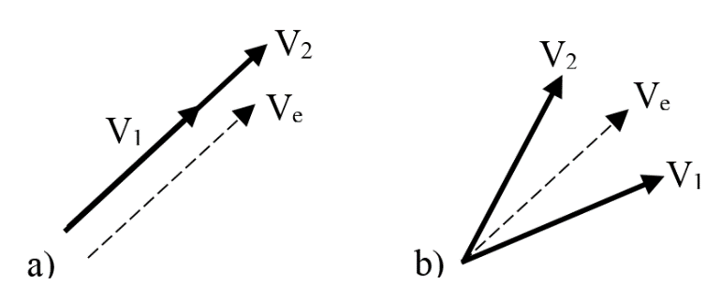

Fig. 1 Transitioning phasors for a) magnitude step, b) phase step

Intermediate phasor estimates can be obtained, for example, using a weighted means out of the estimated model parameters. Using the notation to represent an estimate of , for any , for a waveform with magnitude step described by (1), the estimated intermediate phasor would be

; (5)

and for a waveform with a phase step test described by (2), the intermediate phasor would be

. (6)

## Instantaneous frequency via Hilbert transform

Hilbert transform has been used to estimate instantaneous frequency (IF) of narrowband monocomponent signals, which is the case of ideal electric network phasor components. There are various applications of IF estimation reported in the literature, e.g., characterization of electric disturbances [18] and detection of edits in audio signals that bear the electric network frequency. Anomalous perturbations on the IF can flag the occurrence of discontinuities in the signal. The time instant they happened can be estimated via appropriate amplitude threshold schemes [19].

Given a real narrowband monocomponent signal , let be called the analytic signal associated to , defined as

, (7)

where

(8)

is the Hilbert transform of . If is expressed in the polar form

(9)

, (10)

, (11)

the instantaneous frequency (IF) can be defined as

. (12)

The discretization of , represented by , gives the discrete version of the analytic signal

. (13)

With discrete version of obtained with the fast fourier transform (FFT) [20], the discrete IF can be estimated by the numerical derivation with respect to time of the discrete instantaneous phase angle obtained from (11). Let the detection signal, given by

, (14)

where is the median of . Appropriate threshold schemes applied to can flag the occurrence of fast transients and allow the estimation of the instant of occurrence. Two examples of the detection signal time aligned with the real signal is shown in Fig. 2 and Fig. 3, for magnitude and phase steps.

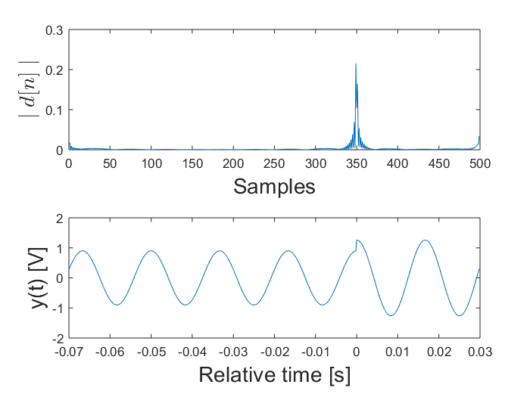

Fig. 2 - Instantaneous frequency of signal with one magnitude step

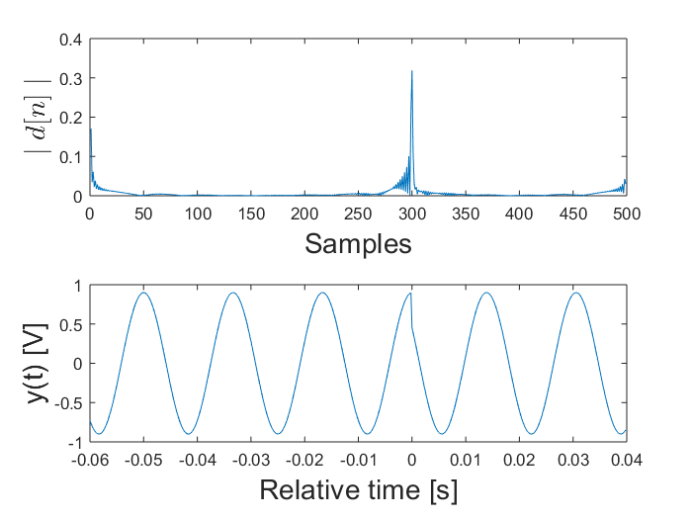

Fig. 3 - Instantaneous frequency of signal with one phase step

## Model Parameters Estimation via Levenberg-Marquardt

Consider samples from a sequence which can be either generated via computational simulation or sampled from measured real phenomenon, with uniform sampling period . One wishes to fit the models (see Section II) with parameters to For that, one can define the error cost function

, (4)

and try to solve the minimization problem

The estimation of phasor parameters considering variations in frequency within the model requires dealing with a non-linear function. Existing calibration systems solve this problem for steady-state signals through low order Taylor linearization [3], or using directly some non-linear minimization algorithm, e.g., Levenberg-Marquardt (LM) [13][14].

The Levenberg-Marquardt (LM) algorithm [15][16] is an iterative technique for nonlinear minimization problems. It combines the Gauss-Newton method and the steepest descent, being very useful when the size of the descendant step cannot be obtained in a closed form. Instead, numerical approximations of the Jacobian matrix are used to estimate the gradient of the cost function and establish an optimal direction. Such NL-LS methods can reach local minima and need a convex cost function, provided by (4).

# Numerical Simulations

We performed Monte Carlo simulations with 1000 runs for each set point, to estimate the errors obtained with the numerical computation of the reference values. The errors will be considered as the contribution of the numerical computations to the uncertainty of the calibration system.

For each run, the input signals were digitally generated, with all nominal parameters prescribed in the standard [1] and random values representative of expected uncertainties in each parameter. The signals were created based on (1) and (2) with a 5 kHz sampling frequency, with a duration of 0.1 s. The nominal values are summarized in Table I, with their respective uncertainties used in simulations.

TABLE I

Nominal values and uncertainties for simulations

|  |  |  |  |  |  |
| --- | --- | --- | --- | --- | --- |
| **Parameter** |  |  |  |  |  |
| **Nominal** | 1 Vp | ± 0.1 | ± 10° | 60 Hz | 360°, ±120° |
| **U[%]** | 1 | 1 | 1 | 0.05 | 1 |

## Step instant estimation with Hilbert transform

Supposing the presence of steps discontinuities, the peaks were detected taking the maximum value of the detection signal , calculated by (14). Detecting whether there is or not a discontinuity is not the purpose here, but can be implemented using appropriate thresholding schemes [7].

If we use an ideal signal without uncertainties in the parameters of the signal generating model and nominal frequency, for a total duration of the window T, , and , (with additive white noise drawn from a uniform distribution), the maximum absolute errors are not greater than .

In a second simulation, designed to represent a more realistic situation, we allowed variation in frequency and 1% variation in the other parameters, all under a uniform distribution. The maximum errors obtained are not greater than for a , with additive zero mean white gaussian noise. The distribution of errors (in units) for positive magnitude step of 10% is shown in a histogram in Fig. 4. Similar histograms were obtained for negative magnitude steps and phase steps of ± 10°, with the same results.

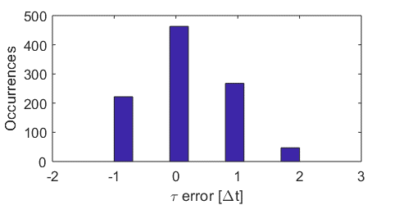

Fig. 4 - Histogram of errors in step instant estimation

## Parameters estimation with non-linear least squares

For the uncertainty analysis reported in this subsection, at each Monte Carlo run, the signal is generated with uncertainties added to the parameters, drawn from a uniform distribution centered in the nominal values, as shown in Table I, along with additive white Gaussian noise at different SNR levels. Maximum errors of ± in the estimation of are also simulated. The intermediate magnitude or phase are calculated with (5) and (6). Each quantity is compared to nominal values to obtain magnitude and phase numerical errors.

In the iterative LM algorithm, the model parameters are initiated at the nominal values, and the optimization procedure seeks for the minimum point of which would be reached at the actual values of the parameters. In practice, for this implementation, iterations are stopped when the convergence criteria is reached.

The final estimates have significantly lower errors than the initial values, despite having some sensitivity to noise. Results for parameters of interest are listed in Table II for magnitude steps, and Table III for phase steps.

TABLE II

Standard deviation of numerical errors for magnitude steps

|  |  |  |  |
| --- | --- | --- | --- |
| SNR [dB] | 90 | 93 | 97 |
| Frequency | 0.14 | 0.1 | 0.06 |
| Magnitude [ | 1.5 | 1.0 | 0.6 |
| Phase [ | 0.4 | 0.1 | 0.06 |

TABLE III

Standard deviation of numerical errors for phase steps

|  |  |  |  |
| --- | --- | --- | --- |
| SNR [dB] | 90 | 93 | 97 |
| Frequency | 0.26 | 0.19 | 0.1 |
| Magnitude | 1.5 | 1.0 | 0.7 |
| Phase [ | 0.17 | 0.11 | 0.07 |

# Laboratory measurements

Aiming at validating the proposed method with real signals, several measurements were made using one digital sampling voltmeter (DSVM) and one arbitrary waveform generator (AWG), controlled by a personal computer (PC) via GPIB. The connections are shown in the block diagram of Fig. 6. The system connections and synchronization are inspired in [21], from which we can consider that the uncertainties inserted by the DSVM can be neglected for this preliminary analysis, and the most part of deviations are due to the AWG.

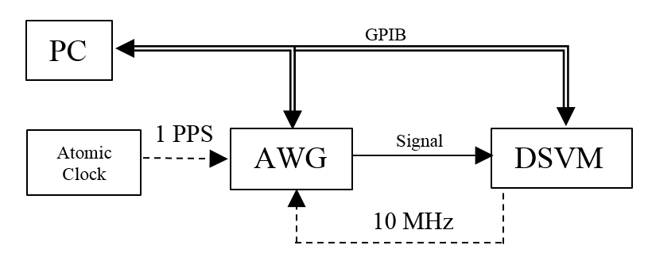

Fig. 6 - Block Diagram

The same waveforms used in simulations are reproduced by the AWG, with a nominal output of , and sampled by the DSVM. Both are triggered with a 1 PPS (pulse per second) signal, coming from an atomic clock, so we can control the initial phase. The internal clock from the DVM is used as an external 10 MHz reference signal by the generator. 5000 samples are taken during 1 s and stored in the DVM´s internal memory.

The standard [1] establishes that the synchrophasors must be obtained related to the center of a window. Setting 500 samples/window, the first complete window will happen after 250 samples, after which we have 9 windows containing 6 cycles of 60 Hz. The steps of magnitude or phase occur in the 5th window, as shown in Fig. 8. According to the procedure for equivalent sampling, the instants of occurrence of the steps are a set of equally spaced intervals .

For the windows with steady state waveforms, the same fitting algorithm used in [3] is used to obtain the synchrophasors and frequency estimates.

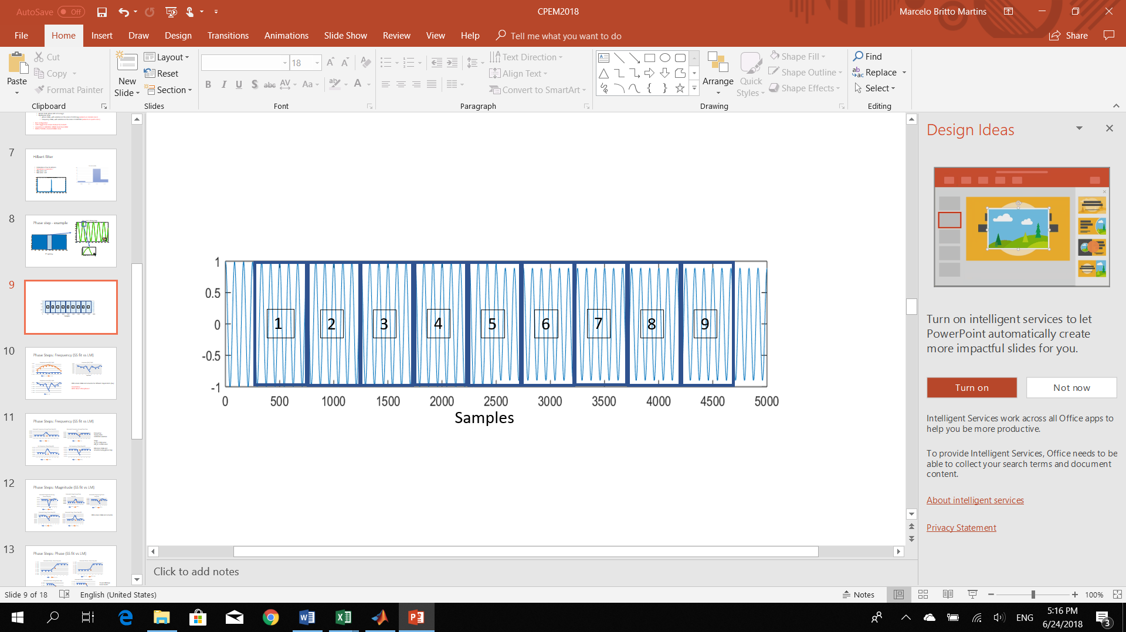

Fig. 5 - Magnitude step occurrence in the 5th window

For the 5th window, the intermediate phasors were calculated using (5) or (6), after obtaining the parameters using the Hilbert algorithm for the step instant, and the-LM algorithm for the others. The frequency was obtained directly from the LM estimation.

The estimates of step instant were not greater than 2, inside the expected uncertainty. The other parameters require a more detailed analysis.

## Intermediate magnitude and phase

The system is capable of providing intermediate values for magnitude and phase, as can be seen in Fig. 7 and Fig. 8, respectively. Each series of data show different step instant occurrences in the 5th timestamp, in percentage of the window period .

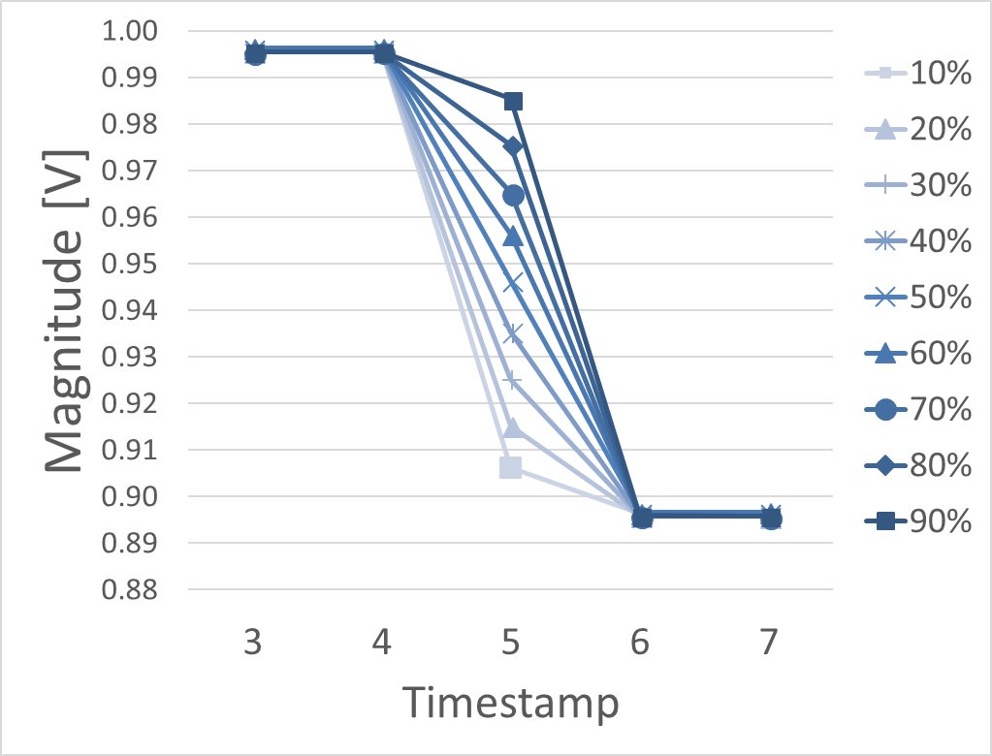

Fig. 7 Intermediate magnitude. Negative step of 10%.

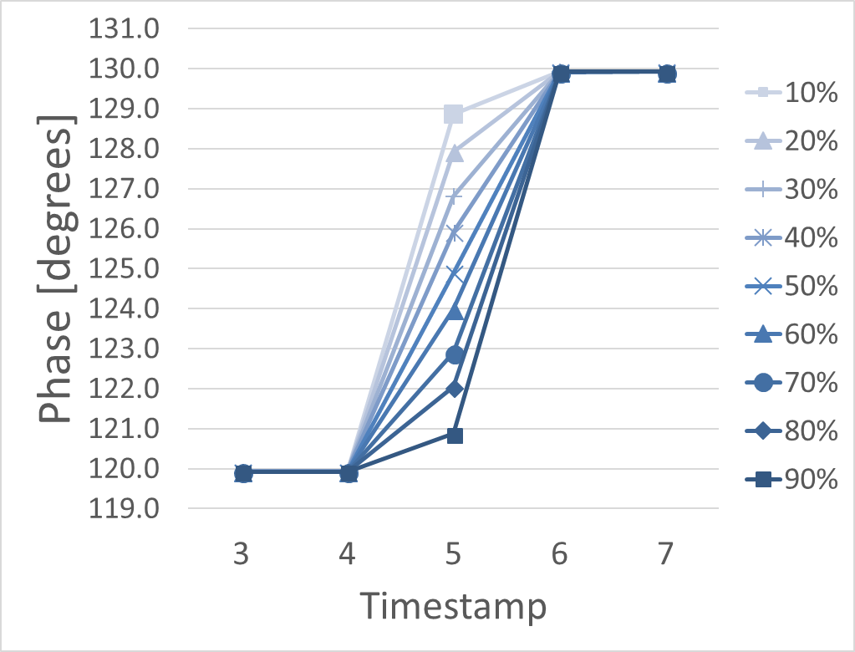

Fig. 8 Intermediary Phase. Phase positive step of 10 degrees, starting at 120 degrees.

## Frequency

Frequency estimates for the analysis windows with steady state signals present standard deviation of errors not greater than (0) from the nominal. When submitted to magnitude steps, the system present standard deviations from the nominal of about (), as can be seen in Fig. 9, where the values for each plot are taken with different step instant occurrences.

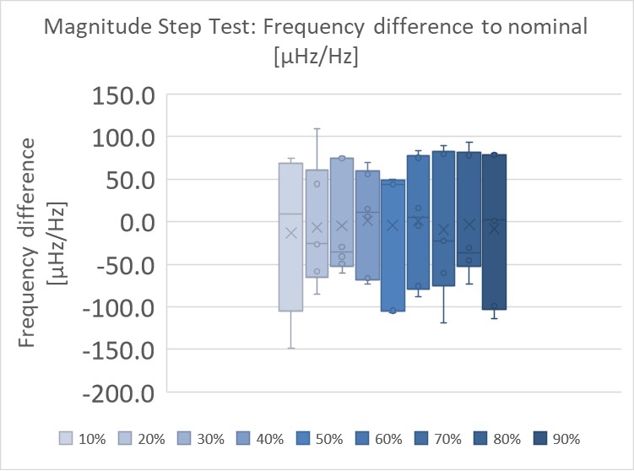

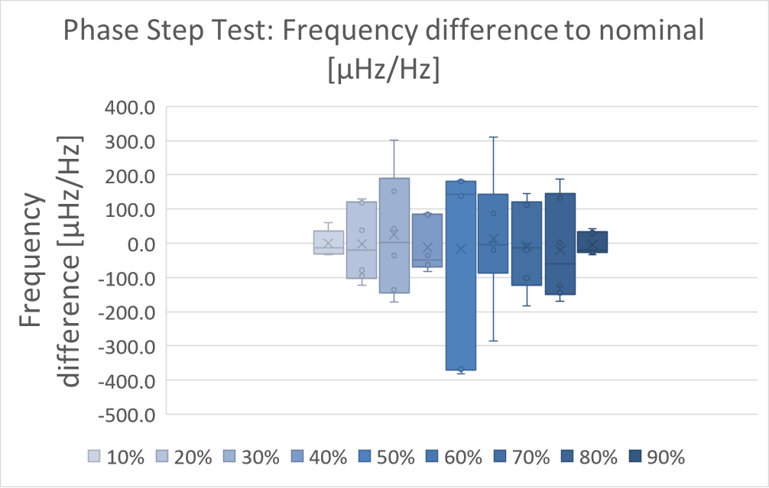Fig. 9 Frequency variation during magnitude tests in function of the step instant.

Fig. 10 Frequency variation during phase steps in function of the step instant.

The worst frequency variations are observed when the system is submitted to phase steps. Shown in Fig. 10, standard variations of about ( can be seen when the phase step occurrence is near the borders of the window, up to (), with the phase step in the middle of the window.

## Magnitude during phase step

During steady state conditions, the magnitude have a standard deviation not greater than . When submitted to phase steps, the magnitude differences to the average values obtained from the steady state phasors show higher values, as shown in Fig. 13, with a standard deviation of .

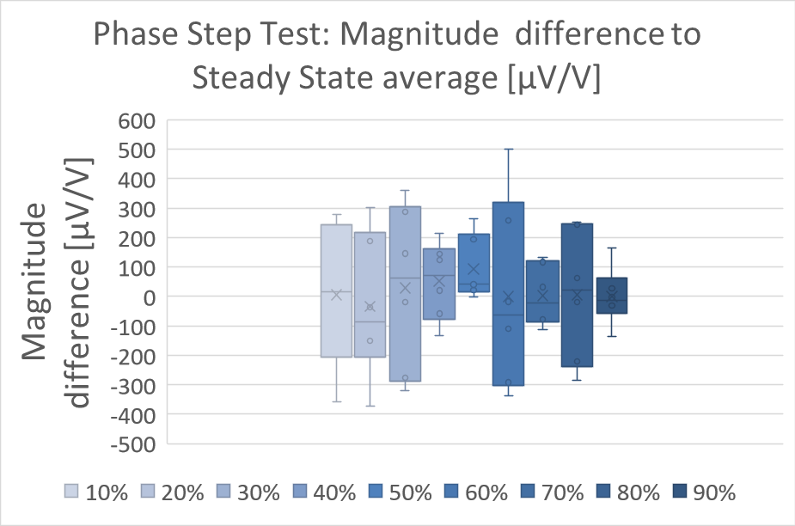

Fig. 11 Magnitude variation during phase steps in function of the step instant of occurrence.

## Phase during magnitude step

During steady state conditions, the phase estimates have standard deviations of about .

Fig. 12 Phase variation during magnitude steps in function of the step instant of occurrence.

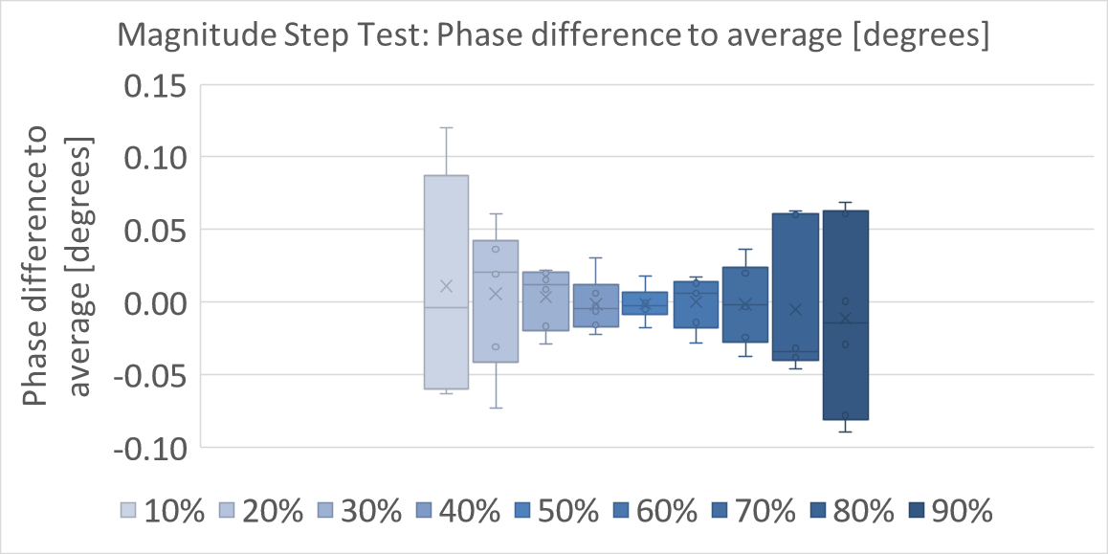

The estimates of phase during magnitude step presents higher variations (standard deviations of ), especially when the step is not centered in half the window, even higher as far as the step occurrence is from the center of the window (standard deviations of ), as can be seen in Fig. 12.

# Conclusion

Models for phasor signals disturbed by magnitude and phase step discontinuity were proposed, in the context of assessment of PMU calibration systems in transient conditions. We present the possibility of observing frequency during magnitude or phase steps, phase during magnitude steps, and magnitude during phase steps. Moreover, intermediate values for magnitude or phase can be estimated to be used as reference values for PMU calibrations.

Estimation of the instant of the step via the instantaneous frequency as provided by the Hilbert transform provided accurate results, which allowed the estimation of the model parameters via a nonlinear least-squares method. The proposed approach tackles the estimation of the step discontinuities in the phasor signal observed within an analysis window, instead of dodging the problem. Moreover, single phasor parameters are proposed for transient conditions, which can be calculated with the estimated parameters from the models.

The estimation accuracy of each parameter and intermediary phasor were obtained under different noise conditions and uncertainties forced upon the model used to generate the test signals. Within the limits reported, the proposed method can give reliable and accurate results to assess PMU calibration systems.

A preliminary analysis of a laboratory system intended to calibrate PMUs was performed, showing higher standard deviations of parameters during transient conditions than those observed during steady state. Significant deviations of frequency during phase steps and of magnitude during

Acknowledgment

Marcelo Martins would like to thank Allen Goldstein, for the valuable comments and guidelines.

References

[1] *IEEE Standard for Synchrophasor Measurements for Power Systems*, IEEE Std C37.118.1-2011*,* Dec. 2011

[2] *IEEE Standard for Synchrophasor Measurements for Power Systems -- Amendment 1: Modification of Selected Performance Requirements*, in IEEE Std C37.118.1a-2014 (Amendment to IEEE Std C37.118.1-2011) , vol., no., pp.1-25, April 30 2014

[3] D. Colangelo *et al*., "Architecture and characterization of a calibrator for PMUs operating in power distribution systems," *2015 IEEE Eindhoven PowerTech*, Eindhoven, 2015.

[4] Y. H. Tang, G. N. Stenbakken and A. Goldstein, "Calibration of Phasor Measurement Unit at NIST," in *IEEE Transactions on Instrumentation and Measurement*, vol. 62, no. 6, pp. 1417-1422, June 2013.

[5] Bollen, Math HJ, and Math HJ Bollen. Understanding power quality problems: voltage sags and interruptions. Vol. 445. New York: IEEE press, 2000.

[6] Phadke, Arun G., and John Samuel Thorp. Synchronized phasor measurements and their applications. Vol. 1. New York: Springer, 2008.

[7] J. Ren and M. Kezunovic, "An Adaptive Phasor Estimator for Power System Waveforms Containing Transients," *in IEEE Transactions on Power Delivery*, vol. 27, no. 2, pp. 735-745, April 2012.

[8] M. de Ápraiz, R. I. Diego and J. Barros, "Transient detection in phasor measurement units with kalman filtering," *2018 18th International Conference on Harmonics and Quality of Power (ICHQP)*, Ljubljana, 2018, pp. 1-6.

[9] J. Barros, M. de Apráiz and R. I. Diego, "A wavelet-based transient detector for P and M class phasor measurement unit integration," *2017 IEEE International Workshop on Applied Measurements for Power Systems (AMPS)*, Liverpool, 2017, pp. 1-6.

[10] A. J. Roscoe, A. Dyśko, B. Marshall, M. Lee, H. Kirkham and G. Rietveld, "The Case for Redefinition of Frequency and ROCOF to Account for AC Power System Phase Steps," *2017 IEEE International Workshop on Applied Measurements for Power Systems (AMPS)*, Liverpool, 2017, pp. 1-6.

[11] A. G. Phadke and B. Kasztenny, "Synchronized Phasor and Frequency Measurement Under Transient Conditions," in IEEE Transactions on Power Delivery, vol. 24, no. 1, pp. 89-95, Jan. 2009.

[12] G. Stenbakken, T. Nelson, M. Zhou and V. Centeno, "Reference Values for Dynamic Calibration of PMUs*," Proceedings of the 41st Annual Hawaii International Conference on System Sciences (HICSS 2008)*, Waikoloa, HI, 2008, pp. 171-171.

[13] FRIGO, Guglielmo et al., “Definition of accurate reference synchrophasors for static and dynamic characterization of PMUs.” in *IEEE Transactions on Instrumentation and Measurement*, vol. 66, n. 9, p. 2233-2246, 2017.

[14] M. B. Martins, R. M. Debatin and A. M. R. Franco, "System for metrological assessment of PMUs under voltage sags," *2016 17th International Conference on Harmonics and Quality of Power (ICHQP)*, Belo Horizonte, 2016, pp. 535-538.

[15] K. Levenberg, "A Method for the Solution of Certain Non-Linear Problems in Least Squares*", Quarterly of Applied Mathematics*, vol. 2, pp. 164-168, 1944.

[16] D. Marquardt, "An Algorithm for Least-Squares Estimation of Nonlinear Parameters", *SIAM Journal on Applied Mathematics*, vol. 11, pp. 431-441, 1963.

[17] M. B. Martins, “Models for Synchrophasor with Step Discontinuities in Magnitude and Phase: Estimation and Performance”, in CPEM 2018

[18] Caciotta, M., et al. "Detection of short transients and interruptions using the Hilbert transform." in *Proc. 19th IMEKO World Congr. Fundam. Appl. Metrol.. 2009*.

[19] P. A. A. Esquef, J. A. Apolinário and L. W. P. Biscainho, "Edit Detection in Speech Recordings via Instantaneous Electric Network Frequency Variations," in *IEEE Transactions on Information Forensics and Security*, vol. 9, no. 12, pp. 2314-2326, Dec. 2014.

[20] Marple, S. L. “Computing the Discrete-Time Analytic Signal via FFT.” *IEEE Transactions on Signal Processing*. Vol. 47, 1999, pp. 2600–2603.

[21] R. T. de Barros e Vasconcellos, V. R. de Lima, W. G. Kürten Ihlenfeld and F. d. Silveira, "Coaxial and Digital Impedance Bridges for Capacitance Measurements at the nF Range," *in IEEE Transactions on Instrumentation and Measurement*, vol. 66, no. 6, pp. 1553-1559, June 2017.

**Marcelo Britto Martins**

**Biography**

**Renata Vasconcellos**

**Biography**

**Paulo A. A. Esquef**

**Biography**

1. This paper was submitted for review in date

   M. B. Martins and R. B. Vasconcellos are with the Brazilian National Institute of Metrology, Quality and Technology, Duque de Caxias 25250-020, Brazil (e-mail: [mbmartins@inmetro.gov.br](mailto:mbmartins@inmetro.gov.br); rbvasconcellos@inmetro.gov.br).

   P. A. A. Esquef is with  the National Laboratory for Scientific Computing, Petrópolis, Brazil (email: pesquef@lncc.br)